DBMS Practical No.: 14

**Name: yash ajay magar**

**Experiment No 14: Implement queries using Aggregate functions**

Exercise:

Consider the following schema

Emp(empno,ename,job,mgr,hiredate,sal,comm,deptno)

1. Display the minimum, maximum, sum and average salary of all employees. Label the columns Maximum, Minimum, Sum and Average respectively.

2. Determine the number of managers without listing them. Label the column number of managers

3. Write a query that will display the difference between the highest and lowest salaries. Label the column DIFFERENCE.

4. Display the number of employees in department 10 who earns a commission

1. Display the minimum, maximum, sum and average salary of all employees. Label the columns Maximum, Minimum, Sum and Average respectively.

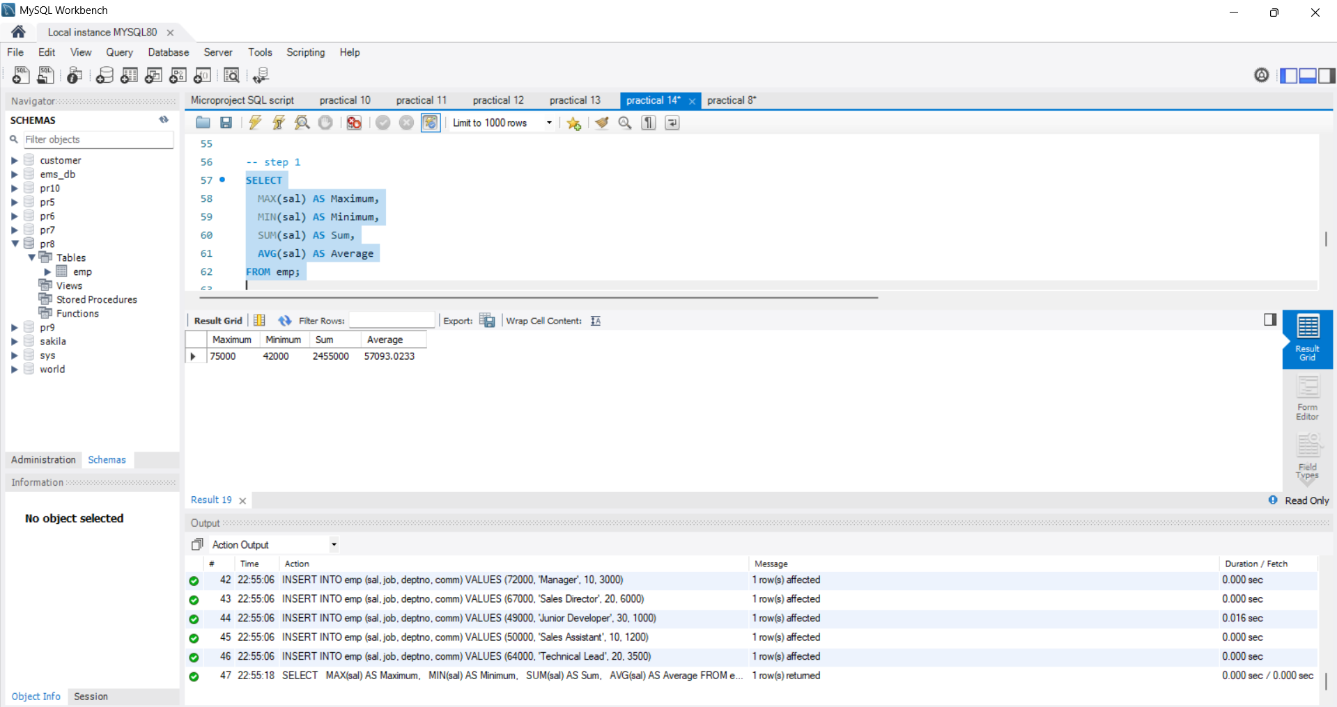

2. Determine the number of managers without listing them. Label the column number of managers

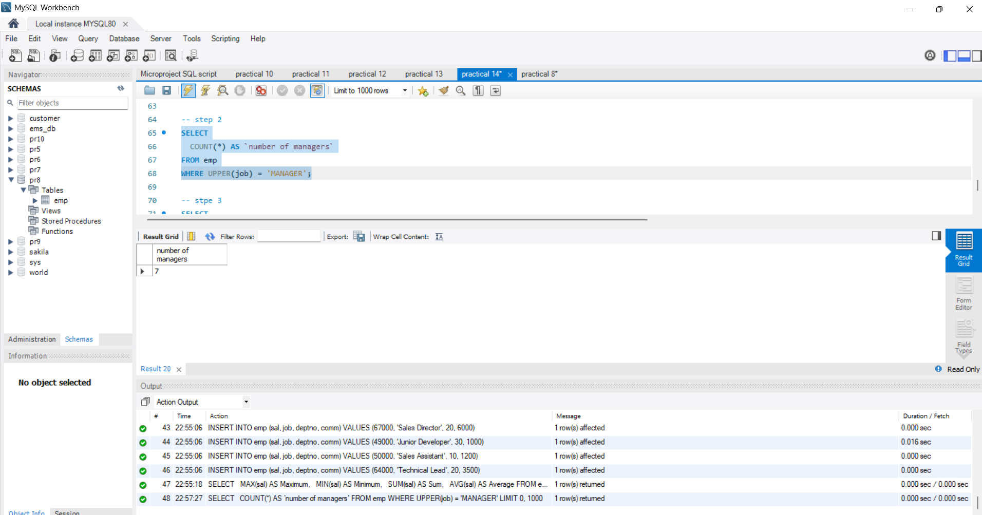

3. Write a query that will display the difference between the highest and lowest salaries. Label the column DIFFERENCE.

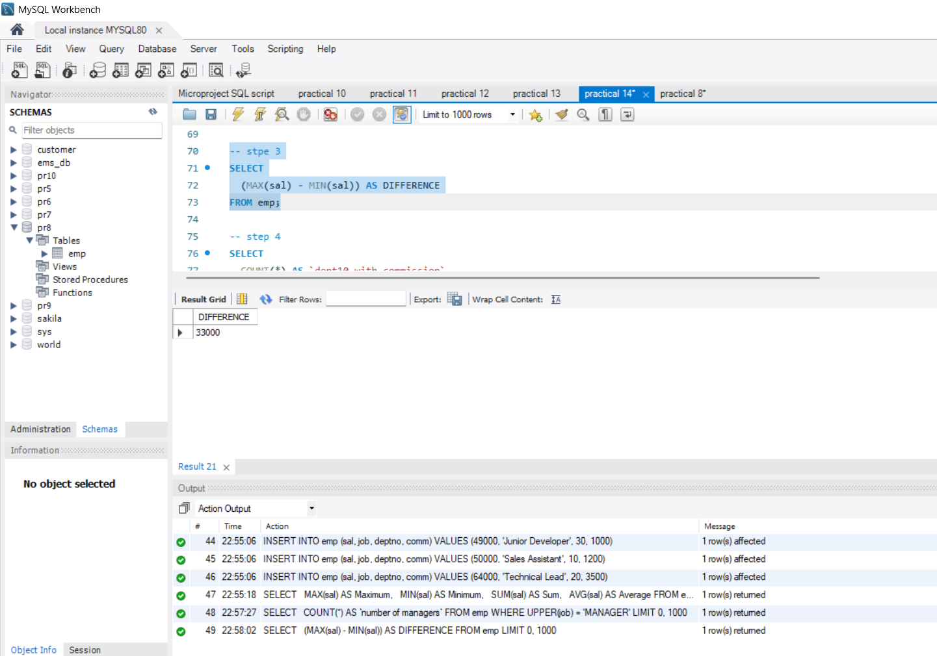

4. Display the number of employees in department 10 who earns a commission

